**Queries**

1. Retrieve the first name and last name of each author in the author relation. Order does not matter. **(1 points)**

**SQL Statement:**

**SELECT lastName, firstName**

**FROM author;**

**Output:**

1. Retrieve the title and book type in the book relation. Order does not matter. **(1 points)**

**SQL Statement:**

**SELECT title, TYPE**

**FROM book;**

**Output:**

1. Retrieve the publisherCode in the book relation. List each publisherCode only once in the result. Order does not matter. **(1 points)**

**SQL Statement:**

**SELECT DISTINCT(publisherCode)**

**FROM book;**

**Output:**

1. Retrieve the title and price of each book in the book relation. Further add a calculated column named ‘discount’ that shows the price the book with 25% discount. Order does not matter. Show the first five rows of the result. **(2 points)**

**SQL Statement:**

**SELECT title, price, (price*.25) AS discount, (price - price*.25) AS discounted_price**

**FROM book;**

**Output:**

1. Retrieve the title and price for any book whose price is higher than $20.00 in the book relation. Show the full result. **(2 points)**

**SQL Statement:**

**SELECT title, price**

**FROM book**

**WHERE price > 20.00;**

**Output:**

1. Retrieve the publisherName of all publishers that are in New York only in the publisher relation. Order does not matter. **(2 points)**

**SQL Statement:**

**SELECT publisherName, city**

**FROM publisher**

**WHERE city = "New York";**

**Output:**

1. Retrieve the publisherName of all publishers that are not in New York in the publisher relation. (use != for inequality). Order does not matter. Show the full result. **(3 points)**

**SQL Statement:**

**SELECT publisherName, city**

**FROM publisher**

**WHERE city != "New York";**

**Output:**

1. Retrieve the bookCode and onHand for each book for which a branch has between 2 and 4 copies in the inventory relation. **Use the BETWEEN keyword in this query.** Order does not matter. Show the full result. **(3 points)**

**SQL Statement:**

**SELECT bookCode, onHand**

**FROM inventory**

**WHERE onHand BETWEEN 2 AND 4;**

**Output:**

1. Retrieve the title and type for each book in the book relation in which the type is SFI, HOR, ART or PSY. **Use the IN operator for this query.** Order the result by type ascending. Show the first five rows of the result. **(3 points)**

**SQL Statement:**

SELECT title, TYPE

FROM book

WHERE TYPE IN ('SFI','HOR','ART','PSY');

**Output:**

1. Retrieve the title for each book in the book relation that begins with the word “The”. Order the result by title ascending. Show the full result. **(3 points)**

**SQL Statement:**

SELECT title

FROM book

WHERE title LIKE 'The%'

ORDER BY title ASC;

**Output:**

1. Retrieve the title for each book in the book relation that doesn’t have a type. Order the result by title ascending. Show the full result. **(3 points)**

**SQL Statement:**

SELECT title

FROM book

WHERE title NOT IN (SELECT TYPE FROM book);

**Output:**

1. Retrieve all of the columns from the author relation. Order the results by the authors lastName descending. **(3 points)**

**SQL Statement:**

SELECT * FROM author

ORDER BY lastName DESC;

**Output:**

1. Retrieve the title and type from the book relation. Order the results first by type and then by title. Both sort keys should be ascending order. Show the first five rows of the result. **(3 points)**

**SQL Statement:**

SELECT title, TYPE

FROM book

ORDER BY TYPE, title ASC;

**Output:**

1. Retrieve a count of the number of books published by Penguin USA. Name the column ‘Penguin Books’. Order does not matter. Show your full result. **(3 points)**

**SQL Statement:**

**SELECT COUNT(publisherName)AS Penguin_Books**

**FROM publisher**

**WHERE publisherName = 'Penguin USA';**

**Output:**

1. Retrieve the publisherCode and the number of books from from publisher from the book relation. Order the result by the count in descending order. Show the first five rows of the result. **(3 points)**

**SQL Statement:**

SELECT COUNT(title)AS number_of_books, publisherCode

FROM book

GROUP BY publisherCode

ORDER BY COUNT(title) DESC;

**Output:**

1. Retrieve the publisherCode and the number of books from that publisher from the book relation. Order the results by publisherCode and only show publishers who have 3 or more books in the relation. **Hint: will need to use the HAVING keyword.** Show your full result. **(3 points)**

**SQL Statement:**

SELECT COUNT(title)AS number_of_books, publisherCode

FROM book

GROUP BY publisherCode

HAVING COUNT(title) >=3

ORDER BY publisherCode;

**Output:**

1. Retrieve the number of books in the book relation whose prices is $20.00 or lower. Order does not matter. Show your full result. **(3 points)**

**SQL Statement:**

SELECT COUNT(title) AS bookCount, price, title

FROM book

GROUP BY price, title

HAVING price <= 20.00;

**Output:**

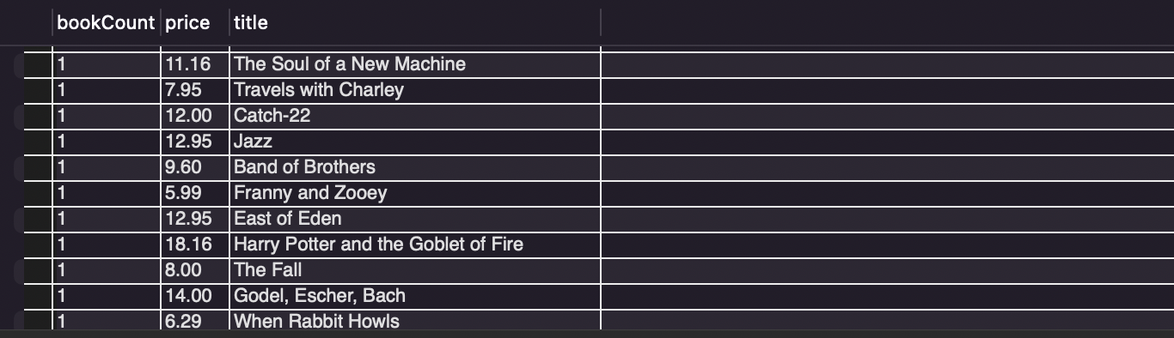

1. Retrieve the title of the most expensive book in the book relation. Use a subquery for this problem. Show your full result. **(3 points)**

**SQL Statement:**

SELECT title, price

FROM book

WHERE price = (SELECT MAX(price)FROM book);

**Output:**



1. Retrieve the title of the least expensive book in the book relation. Use a subquery for this problem. Show your full result. **(3 points)**

**SQL Statement:**

**SELECT title, price**

**FROM book**

**WHERE price = (SELECT MIN(price)FROM book);**

**Output:**

1. Retrieve the title of all books in the book relation that are not published in New York. Order result by the city ascending. Use a subquery for this query. **(5 points)**

**SQL Statement:**

SELECT title, publisherCode

FROM book

WHERE publisherCode IN(

SELECT publisherCode

FROM publisher

WHERE city != "New York");

**Output:**

1. Retrieve all of the columns from the book and publisher relations in one result. Use aliases in your query and use the simple JOIN syntax. Order does not matter. **(5 points)**

**SQL Statement:**

SELECT bookCode, title, b.publisherCode, TYPE, price, paperback, p.publisherCode, city, publisherName

FROM book b, publisher p

WHERE b.publisherCode = p.publisherCode;

**Output:**

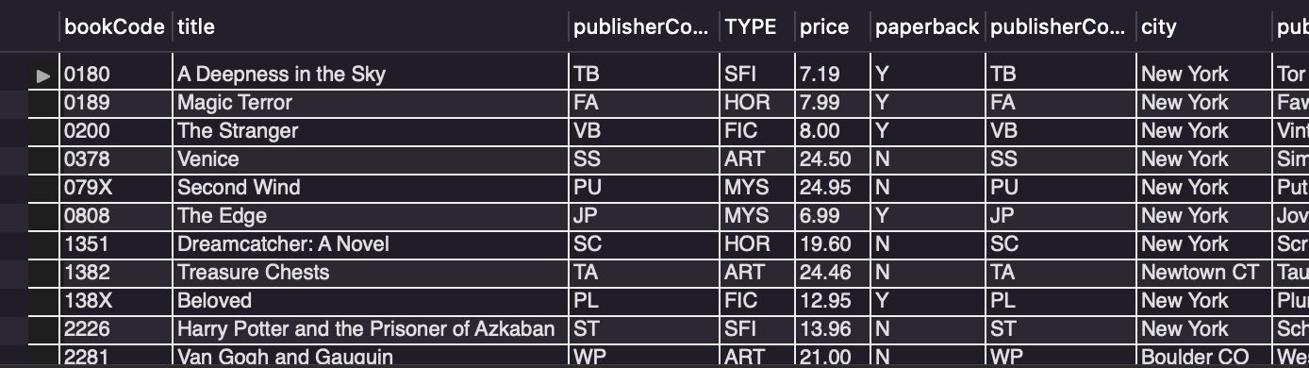

1. Rewrite the previous query using the ON keyword. **(5 points)**

**SQL Statement:**

**Output:**

1. Retrieve the title from the book relation and the city from the publisher relation using a JOIN query. Use aliases in your query. Order the result by title. **(5 points)**

**SQL Statement:**

**SELECT title, city, p.publisherCode, b.publisherCode**

**FROM book b, publisher p**

**ORDER BY title;**

**Output:**

1. Retrieve the title from the book relation and the author lastName from the author relation. Order by author lastName. Use aliases in your query. **This will involve JOINING the book, author and wrote relations.** **(5 points)**

**SQL Statement:**

SELECT title, lastName, b.bookCode, a.authorNum, w.authorNum, w.bookCode

FROM book b, author a, wrote w

WHERE a.authorNum = w.authorNum AND b.bookCode =w.bookCode

ORDER BY lastName;

**Output:**

1. Retrieve the title from the book relation and branchNum and onHand from the inventory relation. Use aliases in your query. Order the result by title. **(5 points)**

**SQL Statement:**

SELECT title, branchNum, onHand, b.bookCode, i.bookCode

FROM book b, inventory i

WHERE b.bookCode = i.bookCode

ORDER BY title;

**Output:**

1. Retrieve the title from the book relation, the branchName from the branch relation and number of copies onHand from the inventory relation. Use aliases in your query. Order the result by title ascending. **(5 points)**

**SQL Statement:**

SELECT title, branchName, onHand, i.branchNum, br.branchNum, b.bookCode, i.bookCode

FROM book b, inventory i, branch br

WHERE i.branchNum = br.branchNum AND i.bookCode = b.bookCode

ORDER BY title ASC;

**Output:**

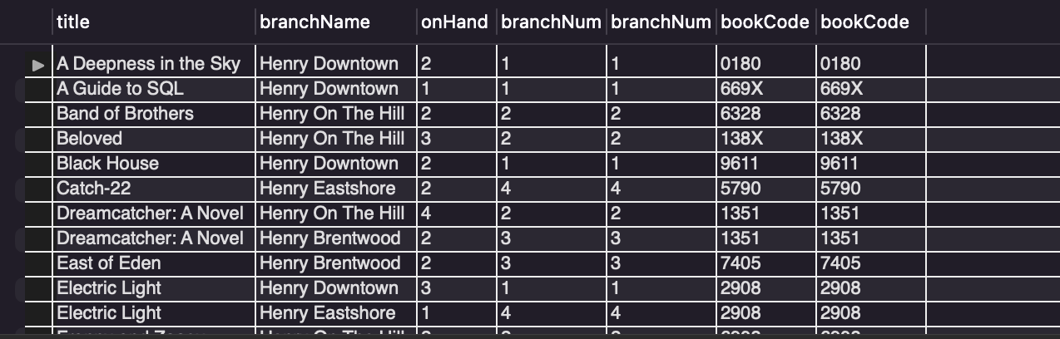

1. Retrieve the title from the book relation and compute the number of copies of the title that all branches have on hand. Name this computed column ‘Inventory’ **Hint: You will need to join book and inventory and do an aggregate query.** Use aliases in your query. Order the result by the total number of copies of the book in descending order. Show the first two rows of your result. **(5 points)**

**SQL Statement:**

**Output:**

1. Retrieve the first name and last name from the author relation and the title from the book relation for all paperback books in the book relation. Order the result by the author last name and title. **(5 points)**

**SQL Statement:**

**Output:**

1. Insert a new branch into the branch relation with the following data branch number = 5, branch name = Henry Lexington Green, branch location = 127 South Road, numEmployees = 7. Then write the query to show all of the branches in the branch relation. **(4 points)**

**SQL Statement:**

**Output:**

1. The Henry Downtown branch moved to 184 St. John’s Way. Update the branch table with the new address. **(3 points)**

**SQL Statement:**

**Output:**